Darkly (pvictor)

# Hack one – md5 cookies

Change the value of the cookies i_am_admin to b326b5062b2f0e69046810717534cb09 (aka true in md5, instead of false as previsous value)

**df2eb4ba34ed059a1e3e89ff4dfc13445f104a1a52295214def1c4fb1693a5c3**

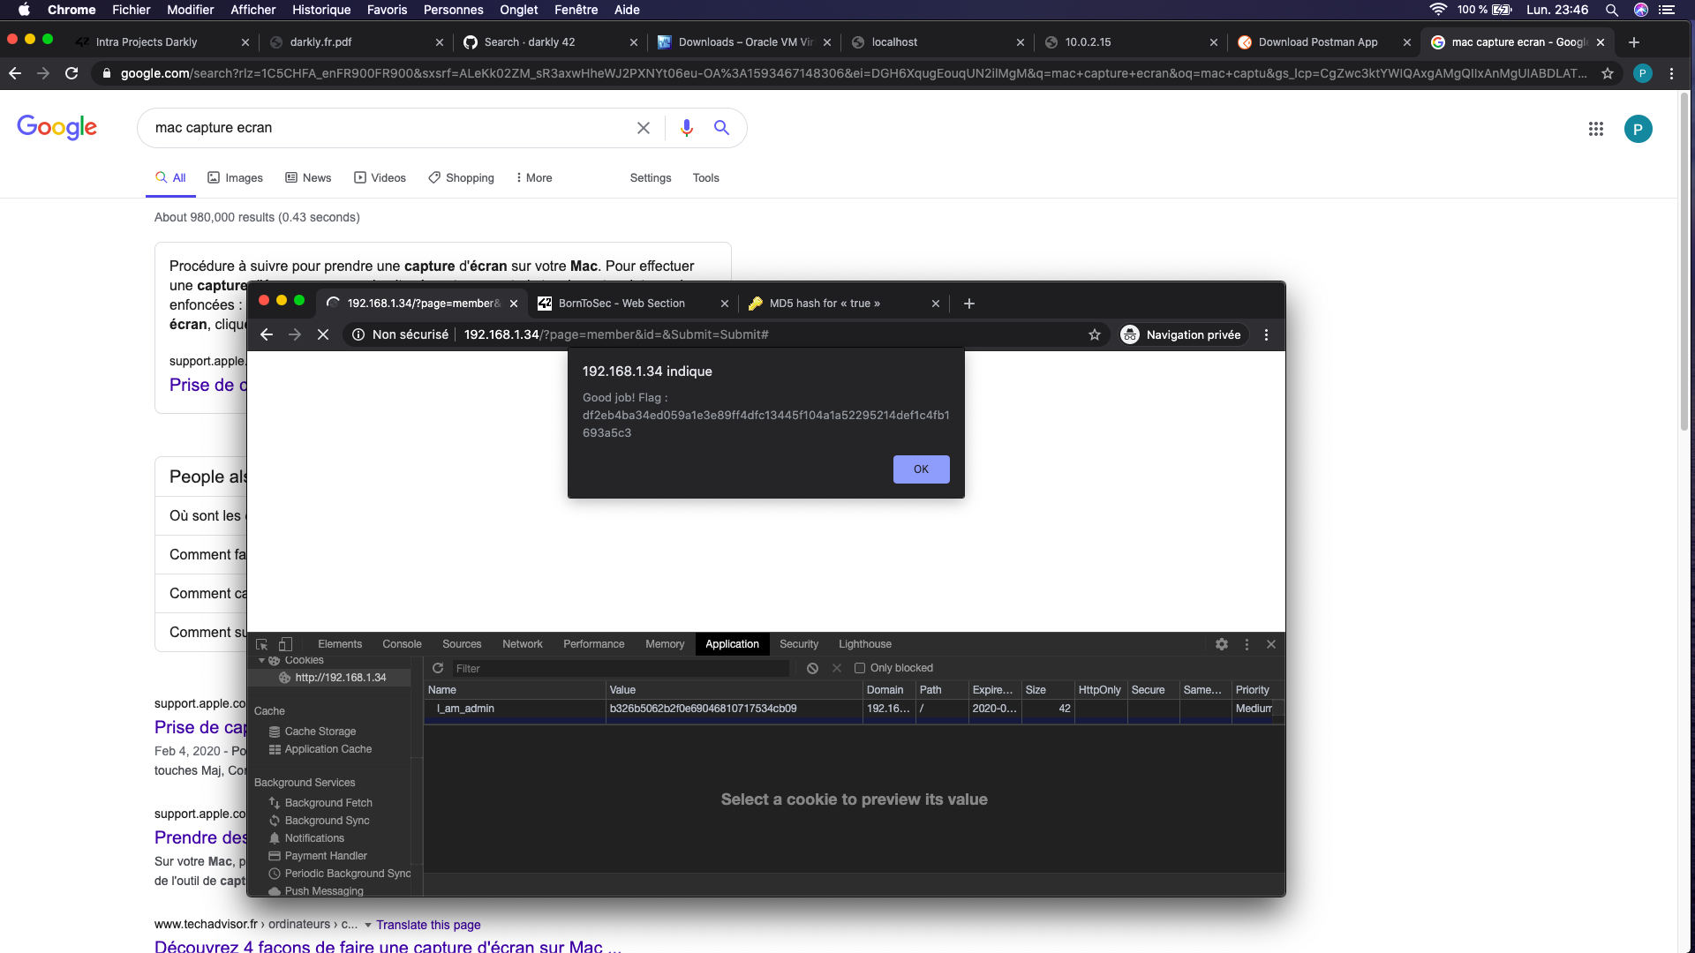

# Hack Two: SQL Injections

Write "<script>alert("loser");</script> in Search Members

We know that the field is not protected agains SQL Injections

# Hack Three: Option tempering

Change the value of the option in the survey to some random number (987987987) and submit the corresponding option.

The data from the users should be tested.

THE FLAG IS 03A944B434D5BAFF05F46C4BEDE5792551A2595574BCAFC9A6E25F67C382CCAA

# Hack XX – password brut force

nmap

<https://null-byte.wonderhowto.com/how-to/brute-force-ssh-ftp-vnc-more-with-brutedum-0197449/>

Try Vega ?

# Key takeways from the project

* No hash values in cookies (use jwt instead)